Move Reverse

Move forward

**Reverse**

Forward

Right side

Left side

Trolley

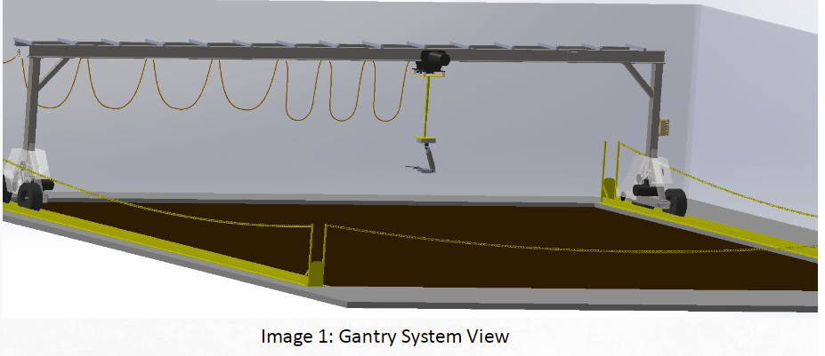

************************************

Keys to Drive the Gantry

************************************

Moving the whole gantry at once:

********************************

Move forward: w

Move reverse: s

Stop: b

Moving the Left side of the gantry only:

********************************

Move forward: d

Move reverse: e

Stop: x

Moving the Right side of the gantry only:

********************************

Move forward: f

Move reverse: r

Stop: p

Moving the Trolley only:

********************************

Move forward: a

Move reverse: t

Stop: o

***Remember that all this keys must be entered in the serial monitor for the Arduino IDE that is connected to the Arduino of the left side.